🏥 Social innovation
Social innovation in health
Social innovation in health means creating and using new ideas to improve healthcare, especially for people who often do not have easy access to it. These ideas are made together with the community so they match real needs and work well in local situations. They can be new ways of working, community projects, mobile health services, education programs, or ways to connect traditional medicine with modern healthcare. The goal is to make health services more fair, easier to reach, and more effective.
Around the world, social innovation in health is supported by the Social Innovation in Health Initiative (SIHI), which started in 2014 with the World Health Organization’s TDR program, the Pan American Health Organization, and other partners. They help countries share experiences, train leaders, and grow projects so they can be used in more places. In different countries, this can mean mobile clinics, training community health workers, creating phone apps for health, or using art and culture to teach about disease prevention.
In Colombia, social innovation in health often means working directly with communities, including Indigenous groups like the Emberá. For example, in Pueblo Rico, projects with Minciencias, SIHI, and local organizations have created health materials such as radio programs, brochures, podcasts, TikTok videos, and songs in the Embera language. These share important health information while respecting traditions and culture. By creating solutions together with the people, these projects improve health knowledge, build trust, and help communities take part in decisions about their own health.

The SIHI LAC Hub is based at the Centro Internacional de Entrenamiento e Investigaciones Médicas (CIDEIM) in Colombia. This hub works to bring together experience, resources, and knowledge from different sectors to support social innovation in health across Latin America and the Caribbean. Their goal is to build strong networks, share lessons, and create evidence that shows how these innovations work and can be expanded.
SIHI LAC helps connect governments, universities, NGOs, communities, and private organizations so they can work together on health challenges. They focus on training people, promoting research, and making sure that successful projects are documented and shared. By combining the strengths of many partners, they make it easier for innovative health solutions to be used in more places and to have a bigger impact.
In Colombia, SIHI LAC at CIDEIM also works with Indigenous and Afro-descendant communities, making sure that health projects are culturally respectful and adapted to local needs. This means using community languages, respecting traditional medicine, and involving community leaders in decision-making, so that health services are not only available but also trusted and used.

SIHI Innovation 2017 // Comprehensive health approach to Chagas disease, Guatemala
Social innovation.mp3
Transcripción en español:
En 2009, Pamela Pennington, investigadora y docente de la Universidad del Valle de Guatemala, enfocó sus esfuerzos en contra de la enfermedad de Chagas con los habitantes de la comunidad de Comapa, un municipio del departamento de Jutiapa, al suroccidente de Guatemala, que cuenta con una población de un poco más de 28 mil personas. Mostraba los índices más altos de infestación y seropositividad en niños de todo Guatemala.
Es una enfermedad que se puede transmitir de madre a hijo. La pobreza lleva a que haya niños que nazcan con esta sentencia de muerte y personas que sigan viviendo con esto, afectándoles a corto plazo.
Las investigadoras Pennington y Sandra de Urioste, junto a un equipo interdisciplinario integrado por biólogos, personas formadas en ecoturismo, antropología y sociología, así como técnicos de campo con amplia experiencia en trabajo comunitario en zonas rurales de Guatemala, decidieron no predeterminar los factores de riesgo del Chagas, sino más bien establecer un diálogo participativo con las comunidades de Comapa para definir con ellas el enfoque del trabajo, identificar sus necesidades y establecer los mecanismos de intervención.
En un primer momento, se centraron los esfuerzos en reducir la posibilidad de reinfestación de los vectores, haciendo que el ambiente, fuera y dentro de las viviendas, fuera menos atractivo para los chinches.
Las universidades han sido de gran beneficio, ya que gracias a ellas se han podido desarrollar diversas actividades en las áreas de campo, específicamente en las áreas afectadas por los altos niveles de infestación de Chagas.
En un segundo momento, se enfocaron en mejorar la provisión de servicios de atención a pacientes con Chagas, diagnosticando la enfermedad con pruebas rápidas en el centro de salud de Comapa.
Finalmente, una tercera fase de la intervención consistió en identificar casos de transmisión del Chagas de madre a hijo en el momento de atender los partos. Sin embargo, como la mayoría de madres gestantes preferían parir en sus casas con ayuda de comadronas, se acercaron a ellas para que ayudaran a remitir a los bebés de un mes de nacidos al centro de salud y determinar si tenían o no la enfermedad.
Otra cosa que fortaleció el proyecto fue la estabilidad de una persona en las áreas donde se ejecutan los trabajos, lo cual permitió que el trabajo se desarrollara mejor, de manera más eficaz, y con mayor participación comunitaria, logrando así que las acciones fueran más eficientes en las zonas más afectadas por Chagas.
Se quisiera llevar esta estrategia a todas las comunidades vulnerables afectadas, para poder llegar a la meta final de la eliminación de la transmisión de esta enfermedad que afecta a la gente más pobre del país. Tal vez, si se pudiera llegar a nivel centroamericano, podría ser una de las metas a corto plazo con el financiamiento adecuado.

Traducción al inglés:
In 2009, Pamela Pennington, a researcher and professor at the Universidad del Valle de Guatemala, focused her efforts on combating Chagas disease with the inhabitants of the community of Comapa, a municipality in the department of Jutiapa, in southwestern Guatemala, with a population of just over 28,000 people. It showed the highest rates of infestation and seropositivity in children in all of Guatemala.
This is a disease that can be transmitted from mother to child. Poverty leads to children being born with this death sentence and people continuing to live with it, affecting them in the short term.
Researchers Pennington and Sandra de Urioste, together with an interdisciplinary team of biologists, professionals trained in ecotourism, anthropology and sociology, as well as field technicians with extensive experience in community work in rural areas of Guatemala, decided not to predetermine the risk factors for Chagas, but instead to establish a participatory dialogue with the communities of Comapa to define the focus of the work together, identify their needs, and establish mechanisms for intervention.
In the first stage, efforts were focused on reducing the possibility of reinfestation by the vectors, making the environment inside and outside homes less attractive to the insects.
The universities have been of great benefit, as thanks to them, various activities have been carried out in the field, specifically in the areas affected by the high levels of Chagas infestation.
In the second stage, the focus was on improving the provision of healthcare services to Chagas patients, diagnosing the disease with rapid tests at the Comapa health center.
Finally, a third phase of the intervention consisted of identifying cases of mother-to-child transmission of Chagas during childbirth. However, since most pregnant women preferred to give birth at home with the help of midwives, the team approached them so they could help refer newborn babies, at one month of age, to the health center to determine whether or not they had the disease.
Another factor that strengthened the project was having a permanent presence in the areas where the work was carried out, which made the work more effective and encouraged greater community participation, thus allowing actions to be carried out more efficiently in the areas most affected by Chagas.
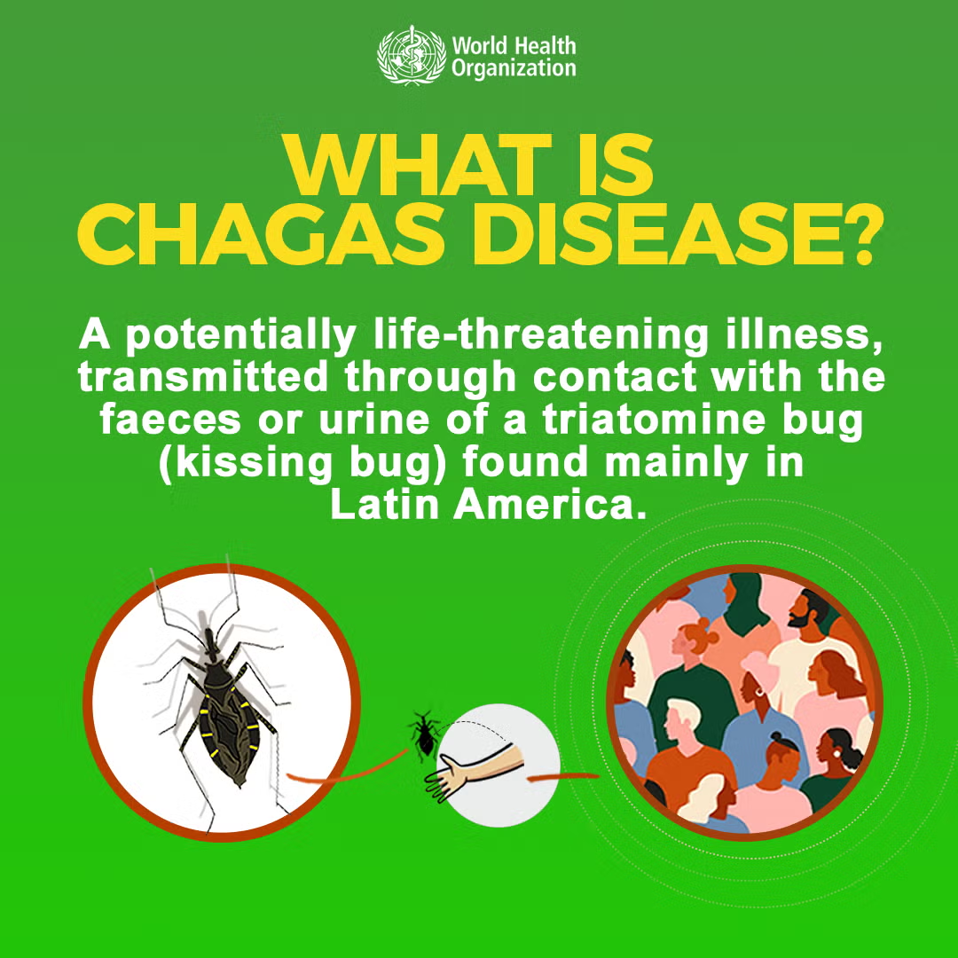
The goal is to bring this strategy to all vulnerable affected communities, in order to reach the ultimate aim of eliminating the transmission of this disease that affects the poorest people in the country. Perhaps, if it could be expanded to the Central American level, it could become a short-term goal with the right funding.

Questions for Milena
- Is this the first time you have heard about Chagas disease?
- What do you know or think about this disease?
- How do you think SIHI LAC and CIDEIM are helping communities affected by Chagas disease?
- In your own words, how would you define “social innovation in health” based on the Chagas disease case?
- How do you think indigenous communities, like the Emberá, could benefit from these innovations?
My short definition for reference:
Social innovation in health means creating new, community-based solutions to improve health and make services more accessible, especially in vulnerable or remote areas. In the Chagas disease case, it involves working with local people, health workers, and partners to detect the disease early, educate communities, and provide better access to treatment.

Listening exercise- True or False
Instructions for Milena

Milena, you are going to listen to a short audio about Chagas disease.

- In the first part, you will answer True or False questions based on what you hear.
- In the second part, you will answer Multiple Choice questions. For each question, you will choose the correct option: A, B, or C.
Listen carefully and answer according to the information from the audio.

Activity
Chagas is the deadliest.mp3
True and False
- Chagas is the deadliest parasitic disease in Latin America by number of deaths. _____
- Chagas is caused by a parasite called Trypanosoma cruzi. _____
- The insect that transmits Chagas feeds only on human blood. ______
Multiple Choice
4. What is the name for the insect that transmits Chagas in Guatemala?
a) Mosquito
b) Chinche
c) Fly
- Where can the transmitting insect hide inside homes?
a) Cracks in adobe or wooden walls
b) Under clean cement floors
c) Roofs made of palm leaves
- What happened in Comapa after spraying with insecticides?
a) The insect infestation completely disappeared
b) There were still high infestation rates and infected children
c) The insect only moved to urban areas

Answers
- True
- True
- False
- b) Chinche
- a) Cracks in adobe or wooden walls, c) Roofs made of palm leaves
- b) There were still high infestation rates and infected children

Chagas

Chagas is the deadliest (by number of deaths) parasitic disease in Latin America. It affects approximately 8 million people in the world, causing an estimated 10,000 deaths each year, especially in populations living in poverty. This disease is caused by the parasite Trypanosoma cruzi, which is transmitted by an insect (Triatomine bug) that in Guatemala is called a chinche. This insect feeds on the blood of dogs, birds, rodents, other animals and humans. It hides inside homes in crevices and cracks in adobe or wooden walls and poorly finished floors, and roofs made of palm leaves.
To eliminate the transmitting insect, in the decade of the 2000s, a strategy of massive spraying with insecticides was implemented throughout Guatemala. Despite this attempt, for the year 2010, the municipality of Comapa had high rates of reoccurrence of Chagas after spraying with insecticides. It also had one of the highest rates of infestation of chinches in homes, and children infected with the parasite.

☺️ Class 2
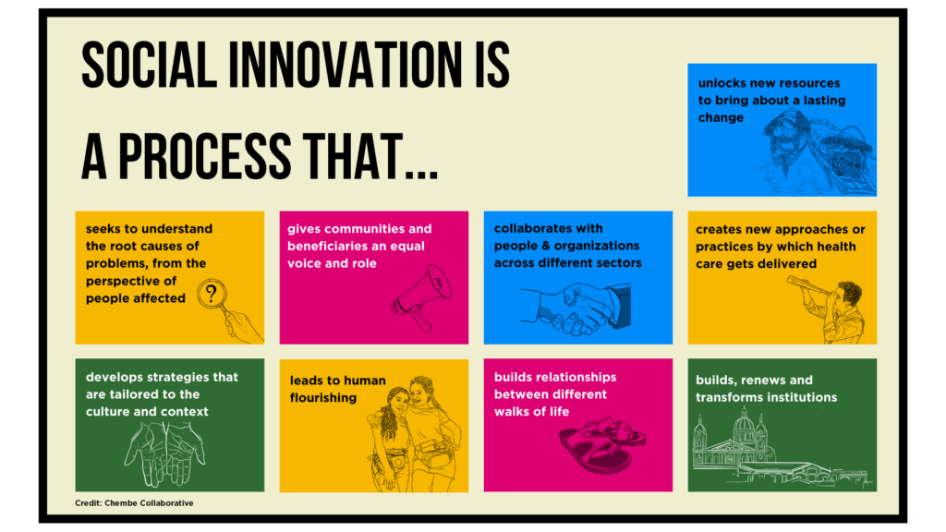

Building the social innovation for health ecosystem in Latin America: experiences and learning from SIHI-LAC

https://innovations.bmj.com/content/bmjinnov/8/3/224.full.pdf
Key Points of the Document
1. General Context
- Social innovation in health has gained importance in Latin America and the Caribbean (LAC) as a strategy to:
  - Reduce health inequities.
  - Promote community participation and empowerment.
  - Transform health systems.
- Unlike Europe (technocratic model), in LAC a democratic paradigm prevails, based on social participation and justice.
2. Current Limitations
- Many initiatives remain local and do not scale to national or regional levels.
- Lack of investment to consolidate supportive ecosystems that strengthen social innovation.
3. Social Innovation Ecosystems
According to Pel et al., an ecosystem includes:
- Local anchoring: hubs and labs providing resources and assistance.
- Translocal connectivity: regional and international exchange networks.
- Discursive resonance: communication structures that grant political and scientific legitimacy.
4. SIHI-LAC (Social Innovation in Health Initiative for Latin America and the Caribbean)
- Established in 2017 as a regional extension of the global SIHI (WHO/TDR).
- Secretariat: CIDEIM (Colombia) and PAHO, supported by universities in Honduras and Colombia.
- Main roles:
  - Identify innovations through open calls (crowdsourcing).
  - Provide support in research, training, networking, and visibility.
  - Recognize initiatives with non-financial awards that build legitimacy.
5. SIHI-LAC Results
- From 2015–2021, supported 8 initiatives in Brazil, Colombia, Guatemala, Honduras, Paraguay, and Peru.
- Key impacts:
  - National and international legitimacy (recognition from PAHO/WHO, new funding opportunities).
  - Influence on health policies (e.g., national Zika protocols in Colombia, community Chagas strategies in Guatemala).
  - Scaling up of projects (e.g., Mamas del Río in Peru-Colombia; MosquitiaMed in Honduras).
  - Inclusion of social innovation in university curricula and national science and technology agendas.
6. Lessons Learned
- Social innovation in health remains under-recognized and invisible; requires stronger diffusion in local communities (radio, TV, community media).
- Relational networking and trust among communities, academia, governments, and NGOs are essential for sustainability.
- Multifaceted communication (scientific publications, short documentaries, local media) is key to influence policy and reach communities.
- Need to strengthen regional sub-networks and establish new hubs in underserved areas (e.g., the Caribbean, remote rural zones).
7. Conclusion
- Social innovation ecosystems in health are essential for achieving real and sustainable impact.
- SIHI-LAC has strengthened ecosystems in Colombia and Honduras, but expansion is needed across more countries.
- Despite limited funding and visibility, these ecosystems are crucial to achieving equity and universal health coverage.

Models of Innovation in Health
Technocratic Model (Europe, more common)
- Vaccination: National plan designed by experts in the capital, based on data and costs, uniformly applied. Communities are only informed to attend.
- Epidemics (e.g., COVID-19): Quarantines and protocols imposed by public health specialists, with no community input.
- Hospitals: Investment concentrated in high-tech urban hospitals, prioritizing efficiency and capacity over rural access.
Democratic Model (Latin America and the Caribbean, more common)
- Vaccination: Community leaders consulted; strategies adapted with mobile brigades, local radio, and indigenous translators. Active community participation ensures access.
- Epidemics (e.g., Dengue, Zika, Chagas): Community health promoters teach mosquito control; local knowledge is combined with scientific medicine; communities join in surveillance.
- Hospitals and Primary Care: Strengthening of community health networks (health posts, midwives, local promoters). Decisions include patient associations and social leaders. Priority is equity of access, not only efficiency.
Summary
- Technocratic = Experts decide, communities follow.
- Democratic = Experts and communities co-create solutions.

References
van Niekerk, L., Echavarria, M. I., Alger, J., Castro-Arroyave, D. M., Bautista-Gomez, M. M., Nieto Anderson, C. I., Beltran, B. Y., & Cuervo, L. G. (2022). Building the social innovation for health ecosystem in Latin America: Experiences and learning from SIHI-LAC. BMJ Innovations, 8(3), 224–233. https://doi.org/10.1136/bmjinnov-2021-000898

PAHO-SIHI Recognized Innovation 2023 // Extramural vaccination strategy for the homeless population

https://www.youtube.com/watch?v=TNxF7ioGstc&t=145s

[Music]
A very endeared song from Brazilian popular music sings that every artist must go where the people are.
The health professionals from Jaboatão, in northeastern Brazil, took this verse as an inspiration during the COVID pandemic and faced head-on the challenge of vaccinating the city's homeless population.
But this initiative didn't just offer vaccines; it aimed to dialogue, understand, and also consider some of their immediate needs. And that's why it worked so well. Now, it's incorporated as a permanent program in Jaboatão.
On the vaccination drives, the city's health teams also register every person in the SUS — the Brazilian national free health system, and in the CadÚnico, the national registry program for social assistance.
Those two programs give them access to other health appointments, exams, and many other welfare benefits, including financial assistance.
[Music]
For City Hall, having a motto means that we must always be close to one another to promote real change — and we plan to keep on doing so.
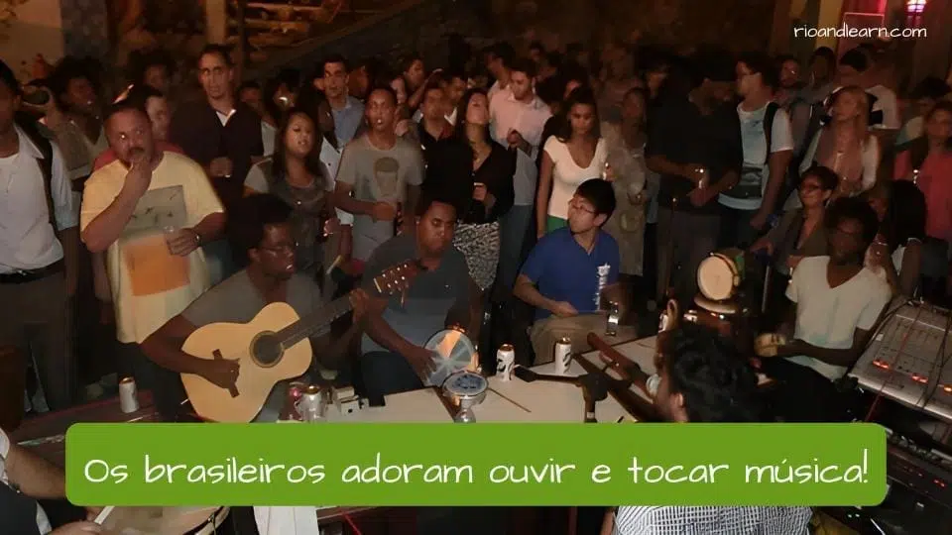
[Music]

Worksheet – Vaccination Program in Jaboatão, Brazil
1. Reflection
The video begins with the phrase: “A very endeared song from Brazilian popular music sings that every artist must go where the people are.”
- What do you think this phrase means?
- Why do you think it inspired the health professionals in Brazil?
- Do you know a similar saying or phrase in Colombia?
2. Context
Where did the initiative take place?
3. Challenge
What was the main challenge faced by the health professionals in Jaboatão during the COVID pandemic?
4. Purpose
Besides vaccination, what else did the initiative aim to achieve?
5. Result
Why did the program work so well?
6. Permanence
What happened after the initiative proved successful?
7. Registration
Which two national programs were homeless people registered in during the vaccination drives?
8. Benefits
What kinds of services and benefits do these programs provide? Name at least two.
9. Values
What does City Hall say is important to promote real change?
10. Critical Thinking
In your opinion, what can Colombia learn from this experience in Brazil?

Answer Key – Vaccination Program in Jaboatão, Brazil
1. Reflection
- The phrase means that artists — or professionals — should be close to the people, not distant.
- It inspired health professionals to go where the homeless population was, instead of waiting for them.
- (Open) In Colombia, a similar saying could be “El pueblo es la voz de la nación” or “Hay que ir donde está la gente.”
2. Context
The initiative took place in Jaboatão, in northeastern Brazil.
3. Challenge
The main challenge was vaccinating the city’s homeless population during the COVID pandemic.
4. Purpose
The initiative also aimed to dialogue, understand, and consider the immediate needs of homeless people, not just give vaccines.
5. Result
It worked well because it was participatory, respectful, and considered the social needs of the population.
6. Permanence
After proving successful, the initiative became a permanent program in Jaboatão.
7. Registration
Homeless people were registered in:
- SUS – the Brazilian national free health system.
- CadÚnico – the national registry program for social assistance.
8. Benefits
These programs provide access to:
- Health appointments and exams.
- Welfare benefits such as financial assistance.
9. Values
City Hall said that being close to one another is essential to promote real change.
10. Critical Thinking
(Open) Possible answers:
- Colombia can learn to include vulnerable groups in national health programs.
- It could also combine vaccination with access to social benefits.
- Another lesson is to involve communities directly to build trust and sustainability.

☺️ Class 3
Building the social innovation for health ecosystem in Latin America: experiences and learning from SIHI-LAC

https://innovations.bmj.com/content/bmjinnov/8/3/224.full.pdf
Key Points of the Document

Models of Innovation in Health
Technocratic Model (Europe, more common)
- Vaccination: National plan designed by experts in the capital, based on data and costs, uniformly applied. Communities are only informed to attend.
- Epidemics (e.g., COVID-19): Quarantines and protocols imposed by public health specialists, with no community input.
- Hospitals: Investment concentrated in high-tech urban hospitals, prioritizing efficiency and capacity over rural access.
Democratic Model (Latin America and the Caribbean, more common)
- Vaccination: Community leaders consulted; strategies adapted with mobile brigades, local radio, and indigenous translators. Active community participation ensures access.
- Epidemics (e.g., Dengue, Zika, Chagas): Community health promoters teach mosquito control; local knowledge is combined with scientific medicine; communities join in surveillance.
- Hospitals and Primary Care: Strengthening of community health networks (health posts, midwives, local promoters). Decisions include patient associations and social leaders. Priority is equity of access, not only efficiency.
Summary
- Technocratic = Experts decide, communities follow.
- Democratic = Experts and communities co-create solutions.

References
van Niekerk, L., Echavarria, M. I., Alger, J., Castro-Arroyave, D. M., Bautista-Gomez, M. M., Nieto Anderson, C. I., Beltran, B. Y., & Cuervo, L. G. (2022). Building the social innovation for health ecosystem in Latin America: Experiences and learning from SIHI-LAC. BMJ Innovations, 8(3), 224–233. https://doi.org/10.1136/bmjinnov-2021-000898
PAHO-SIHI Recognized Innovation 2023 // Extramural vaccination strategy for the homeless population

https://www.youtube.com/watch?v=TNxF7ioGstc&t=145s

[Music]
A very endeared song from Brazilian popular music sings that every artist must go where the people are.
The health professionals from Jaboatão, in northeastern Brazil, took this verse as an inspiration during the COVID pandemic and faced head-on the challenge of vaccinating the city's homeless population.
But this initiative didn't just offer vaccines; it aimed to dialogue, understand, and also consider some of their immediate needs. And that's why it worked so well. Now, it's incorporated as a permanent program in Jaboatão.
On the vaccination drives, the city's health teams also register every person in the SUS — the Brazilian national free health system, and in the CadÚnico, the national registry program for social assistance.
Those two programs give them access to other health appointments, exams, and many other welfare benefits, including financial assistance.
[Music]
For City Hall, having a motto means that we must always be close to one another to promote real change, and we plan to keep on doing so.

[Music]

Worksheet – Vaccination Program in Jaboatão, Brazil
1. Reflection
The video begins with the phrase: “A very endeared song from Brazilian popular music sings that every artist must go where the people are.”
- What do you think this phrase means?
- Why do you think it inspired the health professionals in Brazil?
- Do you know a similar saying or phrase in Colombia?
2. Context
Where did the initiative take place?
3. Challenge
What was the main challenge faced by the health professionals in Jaboatão during the COVID pandemic?
4. Purpose
Besides vaccination, what else did the initiative aim to achieve?
5. Result
Why did the program work so well?
6. Permanence
What happened after the initiative proved successful?
7. Registration
Which two national programs were homeless people registered in during the vaccination drives?
8. Benefits
What kinds of services and benefits do these programs provide? Name at least two.
9. Values
What does City Hall say is important to promote real change?
10. Critical Thinking
In your opinion, what can Colombia learn from this experience in Brazil?

Answer Key – Vaccination Program in Jaboatão, Brazil
1. Reflection
- The phrase means that artists — or professionals — should be close to the people, not distant.
- It inspired health professionals to go where the homeless population was, instead of waiting for them.
- (Open) In Colombia, a similar saying could be “El pueblo es la voz de la nación” or “Hay que ir donde está la gente.”
2. Context
The initiative took place in Jaboatão, in northeastern Brazil.
3. Challenge
The main challenge was vaccinating the city’s homeless population during the COVID pandemic.
4. Purpose
The initiative also aimed to dialogue, understand, and consider the immediate needs of homeless people, not just give vaccines.
5. Result
It worked well because it was participatory, respectful, and considered the social needs of the population.
6. Permanence
After proving successful, the initiative became a permanent program in Jaboatão.
7. Registration
Homeless people were registered in:
- SUS – the Brazilian national free health system.
- CadÚnico – the national registry program for social assistance.
8. Benefits
These programs provide access to:
- Health appointments and exams.
- Welfare benefits such as financial assistance.
9. Values
City Hall said that being close to one another is essential to promote real change.
10. Critical Thinking
(Open) Possible answers:
- Colombia can learn to include vulnerable groups in national health programs.
- It could also combine vaccination with access to social benefits.
- Another lesson is to involve communities directly to build trust and sustainability.
Thursday, 28th

SIHI Sweden
PhD Course in Social Innovation.mp3
PhD Course in Social Innovation
SIHI Sweden successfully conducted a PhD course in Social Innovation from March to April 2025.
- Participants: Six students from different universities in Sweden, with backgrounds in public health, mental health, education, and gender studies.
- Structure:
  - The first two sessions, focused on the fundamental theories of social innovation, were delivered online.
  - The last two sessions were interactive and held in person.
- Activities: A co-creation workshop gave students the chance to brainstorm and design innovative approaches to improve their own PhD projects.
- Final Session: Dedicated to reflecting on the key takeaways from the course and exploring how these insights could be integrated into the students’ ongoing research work.

Social Innovation in Health Initiative. (2025, July). Q2 2025 partner newsletter. Social Innovation in Health Initiative. https://socialinnovationinhealth.org/wp-content/uploads/2025/07/Q2-2025-Partner-Newsletter.pdf

What is a PhD Project?
A PhD project is the central piece of research that a doctoral student develops during their PhD studies. It is usually a long-term, original investigation that contributes new knowledge, methods, or solutions to a field.
Key elements of a PhD project include:
- Research question or problem → What is the issue the student wants to solve or better understand?
- Objectives → What the project aims to discover, explain, or improve.
- Methodology → The tools and approaches used (e.g., surveys, experiments, data analysis, fieldwork).
- Contribution → How the findings will help science, policy, or society.
- PhD thesis → The final written document where the project is presented and defended.

Examples of PhD Projects
- Public Health: “Designing community-based strategies to improve vaccination rates in rural areas.”
- Mental Health: “Exploring how digital therapy apps can reduce anxiety among university students.”
- Education: “Investigating how inclusive teaching methods impact the academic performance of children with disabilities.”
- Gender Studies: “Examining the role of women leaders in advancing climate change policies in developing countries.”
- Social Innovation in Health (like SIHI Sweden): “Co-creating innovative solutions with local communities to improve access to maternal healthcare.”

Colombia Social Innovation in Health.mp3

In Colombia, several initiatives in Social Innovation in Health have been implemented, with strong community participation and a focus on vulnerable populations. For example, the project “Mamas del Río” (on the Colombia–Peru border) trains community health workers and traditional birth attendants to improve maternal and newborn health in remote Amazonian areas. Another initiative, coordinated by SIHI Colombia, focused on community-based strategies against Chagas disease, where families and schools co-created practical solutions such as housing improvements and insect control.
Colombia has also piloted telemedicine and mobile health units to bring healthcare to rural and indigenous populations with limited access to hospitals. These programs are similar to the Brazilian experience, as they not only deliver medical care but also empower communities through participation and dialogue.
Like the PhD course in Sweden, these Colombian projects emphasize co-creation, inclusion, and knowledge sharing. They show how social innovation can be applied in different contexts, whether in academic training or in real-world community health interventions.

😌 Class 4

COMPREHENSIVE CARE MODEL FOR RURAL HEALTH
Sumapaz Locality (Bogotá, Colombia)
Milena Bautista Gómez, PhD

OBJECTIVES

General Objective
Generate new knowledge about social innovation in health in the Latin America and Caribbean region through the documentation of innovative solutions that contribute to a more inclusive, affordable, and effective health care.

Specific Objectives
- Describe the innovative solution in health, in terms of components, strategies, and the implementation process.
- Understand the role of the innovative organization and the links that it establishes with the social and health system.
- Extract lessons learned from social innovations in health with possibilities of replicability and scalability to other health systems.

METHODOLOGY

Research Design
- Qualitative research
- Ethnographic techniques
- Fieldwork performed:
  - November 08–21, 2019
  - February 01–10, 2020

Data Collection
- Grey literature
- Open interviews with beneficiaries and the implementation team
- Discussion groups with innovation leaders
- Field journals about participant observation
- Photo and audio records

Categories of Analysis
- Context
- Solution
- Innovator
- Sustainability, replicability, and scalability
- Key lessons

CONTEXT
Colombia (South America):
- Medium-income country
- High levels of inequality between urban and rural areas
- Health inequalities
Sumapaz (rural locality in Bogotá) faces challenges including:
- Violence
- Barriers to access to rural territory
- Illnesses related to agricultural work
- Limited health infrastructure

COMPREHENSIVE CARE MODEL FOR RURAL HEALTH
Sumapaz Locality (Bogotá, Colombia)
- Created in 2001 by Nazareth Hospital (currently named Subred Sur), the public health institution of Sumapaz District.
- Based on a precise interpretation of the health needs of the rural population, aiming to ensure access to health for farming communities.

Components
- Community participation
- Inclusive and holistic health

Strategies
- 10 networks of community participation
- Home visits
- Health routes
- Food safety and natural medicine
- Chaquén Park (public health park)

Results
- Recognition of health quality
- Decreased mortality and morbidity
- Reduced barriers to access
- Generation of new knowledge
- Community empowerment
- Creation of value for communities

1. THE SOLUTION

1.1 Community Participation
- Knowledge exchange
- Identification of needs
- Community education
Example:
“The first activity was a song alluding to life as a farmer, created by one of the participants. Then the agronomist showed them a recipe for rosemary oil for muscle aches, and the integrative doctor taught a prescription for purging with medicinal plants. The psychologist did a memory, peace, and reconciliation activity. The workshop ended with lunch prepared by the nutritionist-led team: a salad made with vegetables from the communal garden…”
(Field diary, Workshop of the Older Adult Network, Nov. 12, 2019)

1.2 Inclusive and Holistic Health
- One-health approach
- Inclusive strategies
- Interinstitutional management
Quote:
“We do not look at health as levels of care, but in a linear fashion such that we identify the needs as they are addressed… All unite to provide the true and right health, giving a correct and assertive response.”
(Group interview, innovation team, Nov. 14, 2019)

1.3 Food Safety and Natural Medicine
- “Let the food be the medicine and medicine be the food” (Hippocrates)
- Food Safety Program
- Integrative Medicine Program
- Ecotherapy Program (2004–2016)
- Chaquén Park
Quote:
“We worked on medicinal plants because this agricultural population adheres strongly to these treatments. We articulated with integrative medicine and developed actions for families to complement conventional treatments, achieving greater adherence and a holistic health approach.”
(Interview S01, Innovative team, Nov. 13, 2019)

2. ORGANIZATION AND PEOPLE

2.1 Innovative Organization
- Nazareth Hospital (2001–2015)
- Subred Sur (2016–present)
- Expanded upon previous initiatives
- Independent and neutral during the armed conflict
Quote:
“The belief of the government, the community, and the organization was that this was a historic moment. They decided to think differently, to do something different, because such a moment might not happen again.”
(Interview S109, Innovative team, Nov. 15, 2019)

2.2 Implementation Team
- Young people, eager for experience
- Highly motivated and committed to community
- Continuous improvement: “quality circles”
Quote:
“I have learned a lot from colleagues who are always creating new things… We stopped giving lecture-style talks and built participatory workshops instead, making the process fun and easier to learn.”
(Interview, Innovation team, Nov. 13, 2019)

Hello, my name is Milena Bautista Gómez, PhD in Social Sciences, and I would like to share with you a very special research project in which I participated. It is about the Comprehensive Care Model for Rural Health in Sumapaz, Bogotá, Colombia.
My main purpose in conducting this work was to generate new knowledge about social innovation in health in Latin America and the Caribbean, especially through the documentation of innovative solutions that could contribute to making health care more inclusive, affordable, and effective.

Objectives of my research
In this study, I pursued three main objectives:
- To describe the innovative health solution, including its components, strategies, and implementation process.
- To understand the role of the innovative organization and the connections it established with both the social and health systems.
- To extract lessons learned, considering the potential for replicability and scalability to other health systems.

How I carried out the research
The research design was qualitative, using ethnographic techniques. I conducted fieldwork in two different periods: from November 8 to 21, 2019, and from February 1 to 10, 2020.
For data collection, I applied several strategies:
- I reviewed grey literature.
- I conducted open interviews with both beneficiaries and the implementation team.
- I organized discussion groups with innovation leaders.
- I wrote detailed field journals based on participant observation.
- I also kept photographic and audio records.
Later, I structured the analysis around five categories: context, solution, innovator, sustainability/replicability/scalability, and key lessons.

The context of Sumapaz
Colombia, as a middle-income country, has high levels of inequality between urban and rural areas, and this inequality is particularly visible in health. The rural locality of Sumapaz faces several challenges:
- Violence.
- Barriers to accessing rural territory.
- Illnesses related to agricultural work.
- Limited health infrastructure.

The health model
In 2001, the Nazareth Hospital (currently called Subred Sur) created the Comprehensive Care Model for Rural Health in Sumapaz. This model was born from a very precise understanding of the health needs of the farming population, with the aim of guaranteeing access to health services for rural communities.
This model conceives health as:
“a state of complete physical, mental, spiritual, emotional, and social well-being, and not merely the absence of disease or infirmity” (Subred Sur, 2016:7).

Components and strategies
The model was based on two main components:
- Community participation.
- Inclusive and holistic health.
To make this possible, several strategies were implemented:
- Creation of 10 networks of community participation.
- Home visits.
- Health routes.
- Food security and natural medicine programs.
- And the establishment of Chaquén Park, a community public health park.

Results achieved
The model achieved important results:
- Recognition of health quality.
- Decreased mortality and morbidity.
- Reduced barriers to access.
- Generation of new knowledge.
- Empowerment of local communities.
- Creation of social value for the farming population of Sumapaz.

